Name: Pranali Sonawane
Subject: CCNA
Lab – Multilayer Switch with DHCP:
First, we have taken one switch and five PCs. The PCs are connected to the switch using straight-through cables. We used a Multilayer Switch 0 (3560-24PS) because it is a Layer 3 switch.
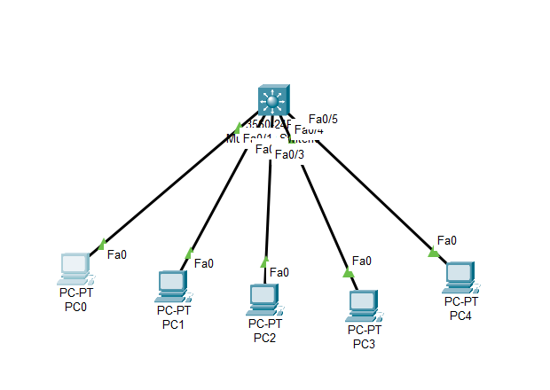
Switch>enable
Switch#configure terminal
Enter configuration commands, one per line. End with CNTL/Z.

!--------------------------
! Interface Fa0/1 - Network 10.0.0.0/8
!--------------------------
Switch(config)#interface fa0/1
Switch(config-if)#no switchport
Switch(config-if)#ip address 10.0.0.1 255.0.0.0
Switch(config-if)#no shutdown
Switch(config-if)#exit

! Create DHCP pool for 10.0.0.0 network
Switch(config)#ip dhcp pool DHCP1
Switch(dhcp-config)#network 10.0.0.0 255.0.0.0
Switch(dhcp-config)#default-router 10.0.0.1
Switch(dhcp-config)#exit

!--------------------------
! Interface Fa0/2 - Network 20.0.0.0/8
!--------------------------
Switch(config)#interface fa0/2
Switch(config-if)#no switchport
Switch(config-if)#ip address 20.0.0.1 255.0.0.0
Switch(config-if)#no shutdown
Switch(config-if)#exit

! Create DHCP pool for 20.0.0.0 network
Switch(config)#ip dhcp pool DHCP2
Switch(dhcp-config)#network 20.0.0.0 255.0.0.0
Switch(dhcp-config)#default-router 20.0.0.1
Switch(dhcp-config)#exit

!--------------------------
! Interface Fa0/3 - Network 30.0.0.0/8
!--------------------------
Switch(config)#interface fa0/3
Switch(config-if)#no switchport
Switch(config-if)#ip address 30.0.0.1 255.0.0.0
Switch(config-if)#no shutdown
Switch(config-if)#exit

! Create DHCP pool for 30.0.0.0 network
Switch(config)#ip dhcp pool DHCP3
Switch(dhcp-config)#network 30.0.0.0 255.0.0.0
Switch(dhcp-config)#default-router 30.0.0.1
Switch(dhcp-config)#exit

!--------------------------
! Interface Fa0/4 - Network 40.0.0.0/8
!--------------------------
Switch(config)#interface fa0/4
Switch(config-if)#no switchport
Switch(config-if)#ip address 40.0.0.1 255.0.0.0
Switch(config-if)#no shutdown
Switch(config-if)#exit

! Create DHCP pool for 40.0.0.0 network
Switch(config)#ip dhcp pool DHCP4
Switch(dhcp-config)#network 40.0.0.0 255.0.0.0
Switch(dhcp-config)#default-router 40.0.0.1
Switch(dhcp-config)#exit

!--------------------------
! Enable IP routing on the multilayer switch
!--------------------------
Switch(config)#ip routing
